Date of current version 2022-02-09

Defect Detection Based on Synthetic Dataset

Yaseen Moolla1

1Applicant

Corresponding author: Yaseen Moolla (e-mail: yaseen.moolla@gmail.com).

ABSTRACT The goal of this exercise is to use machine learning (ML) to perform segmentation on a dataset of synthetically generated gear and spring images. An ensemble of neural networks was designed. In the first step, a classification neural network model was used to determine if the image was of a gear or spring. In the second step, two separate segmentation models were use for gear and spring images respectively, in order to detect regions of defects in the input images. To design the classification model, transfer learning was applied to the VGG16 convolutional neural network (CNN). For segmentation, transfer learning was applied on the DeepLabv3 neural network, which is an existing deep neural network model which has been designed for segmentation. The results are discussed, and suggestions for improvements are made.

INDEX TERMS Machine learning, deep neural networks, transfer learning, computer vision

1. INTRODUCTION

An introduction is already written in the abstract. This exercise is a little small for a full introduction with literature review.

1. PART 1: DEFECT DETECTION IN SYTHETHIC IMAGES

Two separate models were trained for springs and gears, because the shapes of the source objects and the manner in which light reflects off them creates very different images. The DeepLabv3 deep neural network with a ResNet101 backbone is a pretrained model which was chosen as a starting point. It is a popular ML model that is used to identify and segment regions in images. It uses atrous convolution for multiscale segmentation, and is effective with input images of any size. [1]

Transfer learning was applied to the last layer, in order to train the model to recognize the defects in gear and spring images. The DeepLabv3FineTune package [2] was used to apply the transfer learning. Transfer learning allows for fast and effective training when there is a limited dataset.

1. GEARS

An 8:2:1 training:validation:test split was used. This was achieved by leaving 1 folder aside for testing and applying a random 80:20 split on the rest of the 10 synthetic image folders. 5 epochs were used for training, with a total training time of 13 hours on a CPU. (No Cuda-enabled GPU was available for faster and more numerous model generation.) The loss metric used was the mean squared error (MSE).

TABLE I

Performance measurements for gear defect detection

|  |  |  |  |
| --- | --- | --- | --- |
|  | Loss | F1 score | AUROC |
| *Train* | 0.00226 | 0.070 | 0.965 |
| *Validation* | 0.00299 | 0.395 | 0.906 |
| *Test* |  | 0.031 | 0.564 |

Using the standard threshold at

1. Recommendations for Improvement

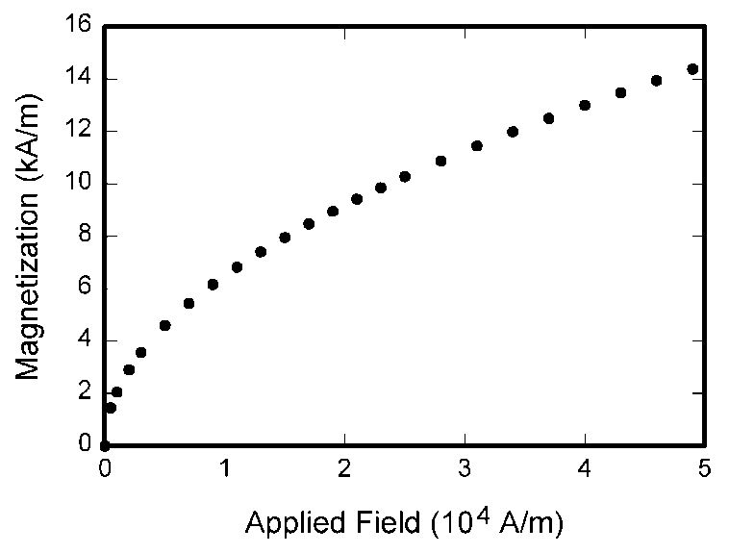

1. Magnetization as a function of applied field. Note that “Fig.” is abbreviated. There is a period after the figure number, followed by two spaces. It is good practice to explain the significance of the figure in the caption.

TABLE I

Units for Magnetic Properties

|  |  |  |
| --- | --- | --- |
| Symbol | Quantity | Conversion from Gaussian and  CGS EMU to SI a |
| Φ | magnetic flux | 1 Mx → 10−8 Wb = 10−8 V·s |
| *B* | magnetic flux density,  magnetic induction | 1 G → 10−4 T = 10−4 Wb/m2 |
| *H* | magnetic field strength | 1 Oe → 103/(4π) A/m |
| *m* | magnetic moment | 1 erg/G = 1 emu  → 10−3 A·m2 = 10−3 J/T |
| *M* | magnetization | 1 erg/(G·cm3) = 1 emu/cm3  → 103 A/m |
| 4π*M* | magnetization | 1 G → 103/(4π) A/m |
| σ | specific magnetization | 1 erg/(G·g) = 1 emu/g → 1 A·m2/kg |
| *j* | magnetic dipole  moment | 1 erg/G = 1 emu  → 4π × 10−10 Wb·m |
| *J* | magnetic polarization | 1 erg/(G·cm3) = 1 emu/cm3  → 4π × 10−4 T |
| χ*,* κ | susceptibility | 1 → 4π |
| χρ | mass susceptibility | 1 cm3/g → 4π × 10−3 m3/kg |
| μ | permeability | 1 → 4π × 10−7 H/m  = 4π × 10−7 Wb/(A·m) |
| μr | relative permeability | μ → μr |
| *w, W* | energy density | 1 erg/cm3 → 10−1 J/m3 |
| *N, D* | demagnetizing factor | 1 → 1/(4π) |

CONCLUSION

A conclusion section is not required. Although a conclusion may review the main points of the paper, do not replicate the abstract as the conclusion. A conclusion might elaborate on the importance of the work or suggest applications and extensions.

APPENDIX

Appendixes, if needed, appear before the acknowledgment.

ACKNOWLEDGMENT

The preferred spelling of the word “acknowledgment” in American English is without an “e” after the “g.” Use the singular heading even if you have many acknowledgments. Avoid expressions such as “One of us (S.B.A.) would like to thank ... .” Instead, write “F. A. Author thanks ... .” In most cases, sponsor and financial support acknowledgments are placed in the unnumbered footnote on the first page, not here.

REFERENCES AND FOOTNOTES

1. REFERENCES

IEEE PUBLISHING POLICY

The general IEEE policy requires that authors should only submit original work that has neither appeared elsewhere for publication, nor is under review for another refereed publication. The submitting author must disclose all prior publication(s) and current submissions when submitting a manuscript. Do not publish “preliminary” data or results. The submitting author is responsible for obtaining agreement of all coauthors and any consent required from employers or sponsors before submitting an article. The IEEE Access

Department strongly discourages courtesy authorship; it is the obligation of the authors to cite only relevant prior work.

The IEEE Access Department does not publish conference records or proceedings, but can publish articles related to conferences that have undergone rigorous peer review. Minimally, two reviews are required for every article submitted for peer review.

PUBLICATION PRINCIPLES

The two types of contents of that are published are; 1) peer-reviewed and 2) archival. The Transactions and Journals Department publishes scholarly articles of archival value as well as tutorial expositions and critical reviews of classical subjects and topics of current interest.

Authors should consider the following points:

1. Technical papers submitted for publication must advance the state of knowledge and must cite relevant prior work.
2. The length of a submitted paper should be commensurate with the importance, or appropriate to the complexity, of the work. For example, an obvious extension of previously published work might not be appropriate for publication or might be adequately treated in just a few pages.
3. Authors must convince both peer reviewers and the editors of the scientific and technical merit of a paper; the standards of proof are higher when extraordinary or unexpected results are reported.
4. Because replication is required for scientific progress, papers submitted for publication must provide sufficient information to allow readers to perform similar experiments or calculations and use the reported results. Although not everything need be disclosed, a paper must contain new, useable, and fully described information. For example, a specimen’s chemical composition need not be reported if the main purpose of a paper is to introduce a new measurement technique. Authors should expect to be challenged by reviewers if the results are not supported by adequate data and critical details.
5. Papers that describe ongoing work or announce the latest technical achievement, which are suitable for presentation at a professional conference, may not be appropriate for publication.

REFERENCES

# References

**There are no sources in the current document.**